This week, my main responsibility was to determine what we should consider when choosing the robot's power supply, and our criteria for this selection.

The robots need power to provide the voltage signals that make the motors turn, the sensors operate and the robot brain. The simplest way of doing so is to use batteries.

As shown in Figure x, the main types of batteries that can be used in robots are;

* NiMh (Nickel – metal hydride battery)
* LiPo (Lithium Polymer Battery )
* Single Cell Batteries

I've done some research about these types of batteries and decided on some of the criteria that we can use when we decide which one to choose.

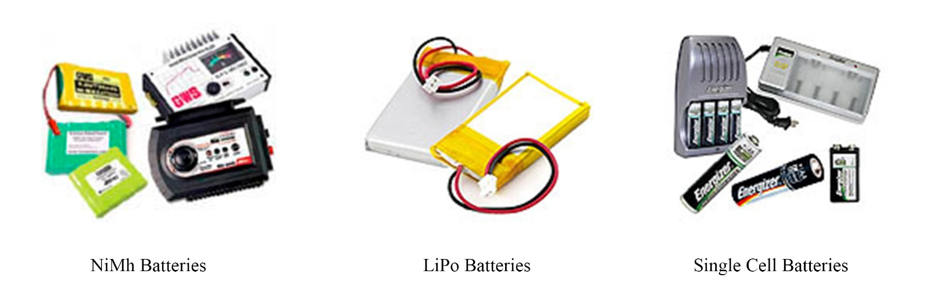

Figure 1: Battery types